Format for Articles of the Journal Investigación Aplicada, un enfoque en la tecnología
(Times New Roman 16) The title must use uppercase and lowercase letters according to proper grammar and spelling. It should summarize the main idea, identify the variables, and indicate the relationship between them (no more than 10 words)..
Author Name Surname¹, Author Name Surname²
(centered text: Times New Roman 10))
(Please write full names and surnames correctly, without abbreviations, and ensure they match the Statement of Originality. Superscript numbers indicate authorship participation, where 1 corresponds to the main author and ^{2–5} to co-authors.)

¹ Affiliation, e-mail: main-author@mail.com
² Affiliation, e-mail: co-author@mail.com
(Up to 5 authors, centered text: Times New Roman 10, italics)
(Please include the authors’ institutional affiliation, if applicable, in the order of the superscripts indicating each author’s contribution to the article, as well as their email addresses, since these are required to assign the DOI.)

Research line:
Abstract
This Word format is a basic guide to prepare articles prior to their publication in the journal Applied Research, A Focus on Technology. The publication is periodic; the dates of the semiannual editions are June 30 and December 31. Articles are received during April/May/June and October/November/December. The abstract must have a minimum of 250 words and a maximum of 500 words. The article must include INTRODUCTION, DEVELOPMENT, GENERAL AND SPECIFIC OBJECTIVES, OBJECT OF STUDY, METHODOLOGY, DEVELOPMENT PHASES, RESULTS AND DISCUSSION, AND REFERENCES. THE DOCUMENT MUST NOT EXCEED 13 PAGES.

Keywords must be listed in alphabetical order, and the research line to which the article is directed must be specified. Example:
Title: Ultrasonic Cane for People with Visual Impairment.
Research line: Software.
Some research lines include: Software, Informatics, Computers, Industrial, Electrical, Administrative, Chemical, Petroleum, Civil, Environment, Food, Agronomy, Mechatronics, Case Studies, Engineering Education, Engineering Ethics, Consulting, Innovation, Entrepreneurship, Related Areas, and Other Engineering Fields.
Articles are written in Spanish; however, manuscripts in English are also accepted.
For the entire document, the following margins will be used: left 25 mm, right 20 mm, top 25 mm, and bottom 20 mm. Use Times New Roman font size 10 for the abstract and do not add extra space between paragraphs; use 1.0 line spacing. For section headings, use Times New Roman 10, BOLD AND CAPITAL LETTERS, except for the main title, which already has its assigned format. For tables and figures, use Times New Roman 10 in bold for the numbering and italics for the titles without bold; capitalize each word except for connectors and prepositions. Titles should be placed above tables and figures. Notes should be placed at the bottom, and for table and figure notes, Times New Roman 10 should be used.

Keywords: Provide 3 to 5 keywords or key phrases, in alphabetical order, separated by commas; use Times New Roman 10 font in italics.

Each section presented below must be fully described; therefore, it must include: INTRODUCTION, DEVELOPMENT, GENERAL AND SPECIFIC OBJECTIVES, OBJECT OF STUDY, METHODOLOGY, DEVELOPMENT PHASES, RESULTS AND DISCUSSION, CONCLUSION AND REFERENCES, in order for the manuscript to be classified as the result of a research study and to provide recognition to the authors through citations.
Avoid:
Cloning: Presenting another person’s work as one’s own, copying it word for word or making slight modifications.
Copy and Paste: Including large fragments of text without proper citation.
Search and Replace: Changing key words or expressions without altering the original content of the sources.
Remix: Mixing paraphrased material extracted from multiple sources.
Recycling: Reusing large passages from previously published articles.
RRS Sources: Correctly citing sources but including little or no original writing.
AI-generated writing (Artificial Intelligence).

INTRODUCTION
In this first part of the article, provide a brief introduction to your work, without expanding on concepts that are already widely known. To prepare your article, it is recommended to strictly follow these instructions, as the electronic file will appear exactly as submitted. To emphasize, use italics; do not underline. Define the related research variables, the associated factors, the general objective, and the specific objectives.
Each topic to be developed must be placed under a subheading to ensure that no section is missing.

DEVELOPMENT
In this section, it is important to briefly describe the impact of the innovation of your research, without expanding the writing in a way that diverts from the central focus of the study.

GENERAL AND SPECIFIC OBJECTIVES
They are based on Bloom’s Taxonomy. The general objective (What is to be achieved?) and the specific objectives (How will it be achieved?—which represent the steps to reach the general objective; it is recommended to include three) must be written using verbs in the base form, in accordance with the levels of Bloom’s Taxonomy.
Examples:
General objective:
Design a technological system to improve process efficiency.
Specific objectives:
Analyze the operational requirements of the system.
Develop the proposed technological solution.
Validate system performance through functional testing.

OBJECT OF STUDY
(State the object of study. The main object of study is the system on which the research is focused and developed, and the importance of addressing that system must be justified.)

Regarding figures: Figures must be numbered using Arabic numerals. The title is placed at the top of the figure; the image must be clear and must be referenced in the text.
Example:
As shown in Figure 2…
The figure number must be written in bold.
The figure title must be written in italics, with each word capitalized except for connectors or prepositions.
Notes must be placed at the bottom of the figure to indicate any explanatory information.
Source must be placed below the figure to indicate its origin.
If the figure contains attached data, it must be legible for the reader.
The figure must be sharp and not opaque or blurry.

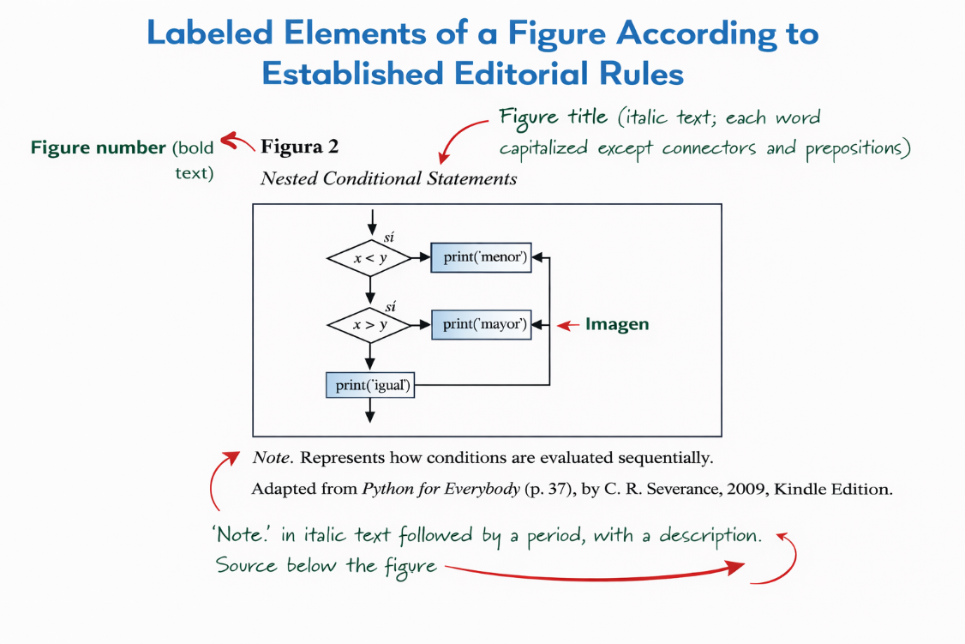
Figure 1
System Architecture of the Proposed Model
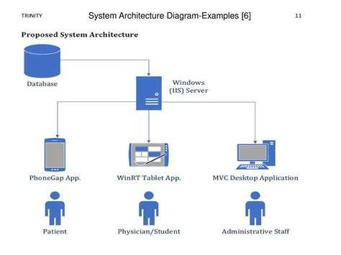
Note. The diagram illustrates the proposed system architecture, showing the interaction between the database, the Windows (IIS) server, and the different applications used by patients, physicians/students, and administrative staff.

Regarding tables: Tables must be separated using horizontal lines and numbered with Arabic numerals, in the order in which they are mentioned in the text. The title must be placed at the top of the table and must be referenced in the text before or after it is presented.
Example: As shown in Table 1…
Table borders: Limit the use of borders or lines in a table to those necessary for clarity. In general, a border is used at the top and bottom of the table and below the column headings. A border may be used to separate a row containing totals or summaries from other rows. Do not use vertical borders to separate data and do not place borders around each cell. Use spacing between columns and rows, as well as strict alignment, to clarify the relationships among table elements.
The table number must be written in bold.
The table title must be written in italics, with each word capitalized except for connectors or prepositions.
Notes must be placed at the bottom of the table to indicate any explanatory information.
Source must be placed below the table to indicate its origin.

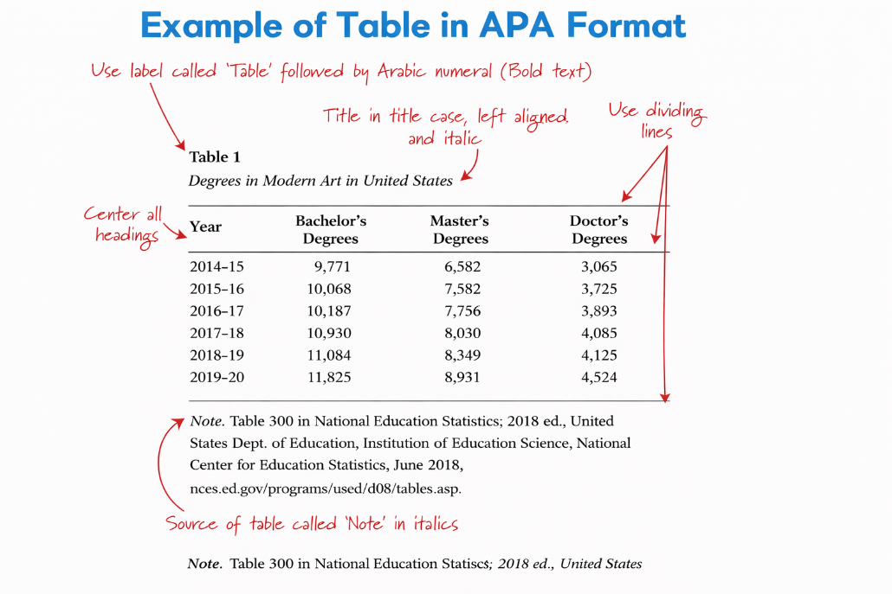

METHODOLOGY
(Describe the methodology used in the research and justify why it was selected. It may be a scientific methodology (quantitative, qualitative, or mixed) or a technological development methodology (spiral, waterfall, prototype, SCRUM, among others), as well as its general phases.)

Regarding writing style
Comments for research writing.
Scientific reports are written in an impersonal manner. Personal pronouns and possessive adjectives such as “I,” “my,” “we,” and “our” should not be used.
Examples:
In the present study, the aim is to…
The objectives of the present research…
The author has found that…
The author’s interest focuses on…
Avoid paragraphs composed of a single sentence, as well as excessively long statements. If a paragraph is too long, identify an appropriate point to divide it and reorganize the material so that it remains coherent. A paragraph should contain a minimum of four lines and a maximum of nine lines.
Writing should use a sober and objective language, avoiding colloquial expressions.
Writing should avoid absolute terms or superlatives; if they are used, they must be supported by a citation or by the results of a verifiable study.

Regarding the use of abbreviations:
At their first occurrence, the full name of the institution, government agency, association, or organization—especially those with long names—must be written out in full, followed by the abbreviation in parentheses. In subsequent mentions, only the abbreviation should be used.
First citation in the text:
National Council for Teaching and Research in Psychology (CNEIP)
Thereafter, only CNEIP
Numbers lower than ten are written in words (Meneses Morales, 1962), except in the following cases:
a) When they appear within a series; for example: 2, 9, 11, and 12.
b) When indicating a page number; for example: …as indicated on page 6.
c) When comparing two-digit numbers used within the same paragraph; for example: the case of 3 of the 17 subjects interviewed.
d) When stating age, follow this general rule: numbers lower than ten are written in words, and numbers greater than ten are written as numerals. For example: Three subjects with an average age of 15 years were studied.
Dates are always written using numerals; for example: October 27, 1986.

DEVELOPMENT PHASES
(Describe each of the phases of the methodology mentioned in the previous subheading and their results; preferably include evidence to support the research (screenshots and photographs).

Number equations consecutively using parentheses, aligned to the right margin, as in (1). To write the equation, use the equation editor (left-click on the toolbar | Customize | Commands | Insert, and drag the equation editor to the toolbar). Then select the “Equation” marker style. Press the Tab key and type the equation number in parentheses. Use parentheses to avoid ambiguities in denominators. Punctuate equations when they are part of a sentence, as in:
(1)
Ensure that the symbols used in your equation are defined before or immediately after the equation appears. Refer to it as “(1),” not “Eq. (1)” or “equation (1),” except when it begins a sentence: “Equation (1) is…”.

Units
Use the International System of Units (SI). English units may be used as secondary units (in parentheses). For example, it is acceptable to write “15 Gb/cm² (100 Gb/in²).” An exception applies when English units are used to commercially designate a product, such as a 3½″ diskette or a 2.0″ LCD screen.

Other recommendations
Leave a space after periods and commas. Avoid vague expressions such as “Using (1), the potential was calculated” [it is unclear who or what used (1)]. Instead, write “The potential was calculated using (1),” or “Using (1), we calculated the potential.”
Use a zero before the decimal point: “0.25,” not “.25.” Use “cm³,” not “cc.” Indicate dimensions for each value, such as “0.1 cm × 0.2 cm,” not “0.1 × 0.2 cm².” The abbreviation for seconds is “s,” not “sec.” Do not mix full words with unit abbreviations.
If desired, you may write in the first person singular or plural and use the active voice (“I observed that…” or “we observed that…”) instead of “It was observed that…”. Pay close attention to spelling.

RESULTS AND DISCUSSION
(State the general results obtained and validate them; the section may include statistical data that support the results along with their interpretation)

In-text citations
To cite any text or idea within the document being written, it is necessary to give proper recognition to the author who supports the writing; therefore, all cited or paraphrased sources must be properly acknowledged in the document.
Types of citations:

Narrative citation (author-based): This type of citation is known as author-based because the author’s last name (or authors’ last names) appears at the beginning of the sentence, followed by the selected text that supports the narrative. If it is a direct quotation (which appears exactly as written by the cited author and is an exact copy of the author’s argument), it must be enclosed in quotation marks, and the year, separated by a comma, as well as the page or paragraph number, must be placed in parentheses at the end.
Example:

Apple and Beane (2005) state that influencing the social context to make it favorable for study and learning has “a lasting effect on the lives of children, educators, and the communities served by schools” (p. 28).
Muñoz (2006) defines a hypothesis as “the anticipated and provisional explanation of an assumption that is intended to be tested or disproved, based on the background information collected on the previously defined research problem” (p. 94).

If it corresponds to an indirect citation (it is not an exact copy of what the author states, but rather a paraphrase of the cited author’s ideas; therefore, most of the writing must be the researcher’s own), the author’s last name and the year of publication should be included in parentheses.
Example:
- To support data integrity, Pérez (2008) states that the consistency and accuracy of stored data must be preserved; a relational DBMS generally enforces one or more data integrity constraints.
- Pérez (2008) emphasizes that once an error is detected in any table of a database, it is essential to repair it; if this is not possible, recovery should be performed using a backup copy or an update log file.

Parenthetical citation (text-based): In this type of citation, greater emphasis is placed on the text; therefore, it is based on the information rather than on the author’s prominence. The sentence begins with the text that supports the research enclosed in quotation marks if it is a direct quotation (which appears exactly as written by the cited author and is an exact copy of the author’s argument). At the end of the sentence, the author’s last name, followed by a comma, the year, followed by another comma, and the page or paragraph number of the citation are placed in parentheses.

Example:
- “Influencing the social context to make it favorable for study and learning has a lasting effect on the lives of children, educators, and the communities served by schools” (Apple & Beane, 2005, p. 28).
- A hypothesis is defined as “the anticipated and provisional explanation of an assumption that is intended to be tested or disproved” (Muñoz, 2006, p. 94).

If it corresponds to an indirect citation (it is not an exact copy of what the author states, but rather a paraphrase of the cited author’s ideas; therefore, most of the writing must be the researcher’s own), the author’s last name and the year of publication should be placed in parentheses at the end.
Example:
- An educational practice will be more or less successful depending on the theory on which it is based. One of the main tasks of the sociology of education is precisely to analyze which theories lead to greater success in educational practices and which, on the contrary, lead to failure (Aubert et al., 2008).
- Houses and rooms are filled with perfumes; shelves are laden with fragrances—I breathe in the scent myself, recognize it, and enjoy it, yet the distillation would also intoxicate me, and I must not allow it (Whitman, 1995).

When a direct quotation (which appears exactly as written by the cited author and is an exact copy of the author’s argument) contains more than 40 words, quotation marks are omitted. The quotation is separated from the main text and presented as a block with an indentation of 0.7 cm on each side. It may be presented as either a parenthetical or a narrative citation.

Example:
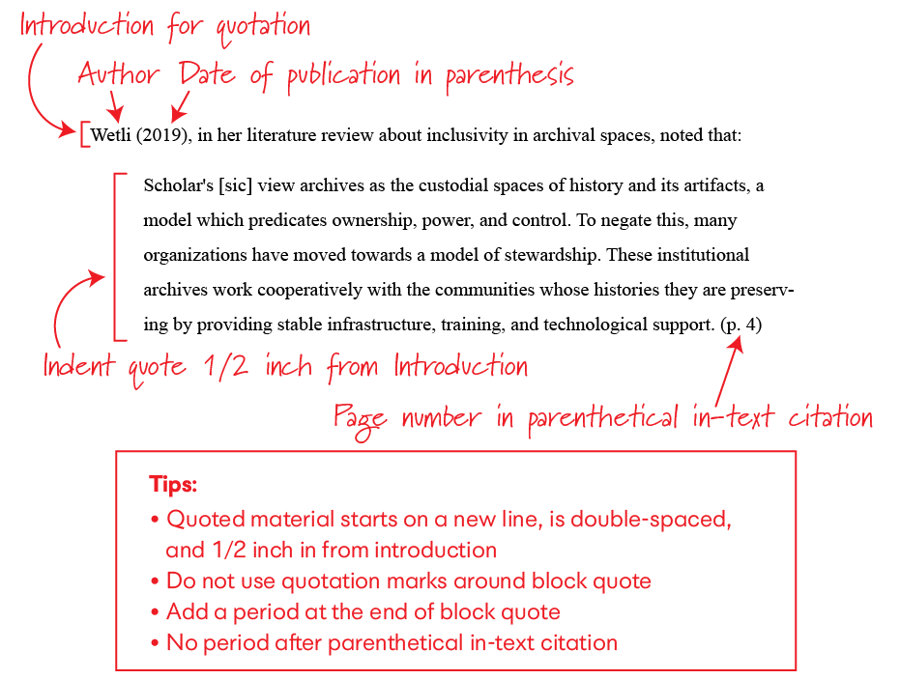

CONCLUSION
(Write the general conclusion of the research.)
A conclusion should emphasize the main points of the article. Do not repeat the abstract as the conclusion. A conclusion may highlight the importance of the work or suggest applications and complementary future work.

REFERENCES
The references must be listed in alphabetical order and must include the page or paragraph numbers of all direct quotations (which appear exactly as written by the cited author and are an exact copy of the author’s argument) included in the article, whether they are parenthetical or narrative citations, as well as any other bibliographic support or source worthy of mention.
Do not use footnotes; it is preferable that the information be included directly in the text.
Reference formats (APA 7)

Single author
Surname, A. A. (Year). Title of the book. Publisher.
https://doi.org/xxxxx (if applicable)
Two or more authors
Surname, A. A., & Surname, B. B. (Year). Title of the book. Publisher.
https://doi.org/xxxxx (if applicable)
Book chapter
Surname, A. A. (Year). Title of the chapter. In A. A. Surname (Ed.), Title of the book (pp. xx–xx). Publisher.
https://doi.org/xxxxx (if applicable)
Journal article
Surname, A. A. (Year). Title of the article. Title of the Journal, Volume(Issue), xx–xx.
https://doi.org/xxxxx
Online document / web page
Surname, A. A. (Year). Title of the document. Website Name. URL
(Do not use “Retrieved from” unless a retrieval date is required.)
Newspaper or magazine article with website
Surname, A. A. (Year, Month Day). Title of the article. Title of the Newspaper or Magazine. URL

